Statistical signal analysis using wavelet transform

Anna Ušáková, Radoslav Vargic, Ivan Kotuliak
Dept. of Telecommunications
Slovak University of Technology
812 18 Bratislava, Slovakia
Email: {usakova, Vargic, ikotul}@ktl.elf.stuba.sk

Abstract

This paper focuses on the statistical properties of the traffic like self similarity. Using wavelet transform, we show the dependencies between their coefficients and present a method of traffic synthesis deploying wavelet transform.

1. Introduction

Wavelet transform is often used as time-scale signal analysis tool. Statistical signal analysis is crucial part of research in several technical domains, including network performance and signal processing field. In this article, we investigate statistical properties of signals and their representations in wavelet domain. This work focuses on the relationship between some statistical signal properties in time and wavelet domain and dependencies between coefficients at different scales in hierarchical wavelet domain representation. Example signal analysis is performed on real network traffic data and on still images.
The rest of the paper is organized as follows: Section 2 provides background information of the statistical properties of traffic In the communication networks. Section 3 introduces Discrete Wavelet Transform (DWT). Section 4 contains model under study and analysis of obtained results. Concluding remarks and scope of future work are given in Section 5.

2. Network traffic consideration

Network traffic is one of the crucial questions of performance analysis. Consequently, a lot of investigation is done in this field. Our main interest is on the LRD (Long Rage Dependence) traffic, having self similar behavior [1,2].
Self similarity can be described as a property of the traffic, when this one holds its variance in different time scales. As it is described in the later section, DWT is suitable tool, while it lets us to decompose traffic to different time scales and study it. Self similarity can be characterized by Hurst parameter (H).

3. Wavelet transform

Wavelet transform [3] offers effective time-frequency representation of signals. All basis functions are formed by shifting and scaling of "mother" wavelet function :
$ψ_{m,n}\left(t\right)=2^{−\frac{m}{2}}ψ\left(2^{−m}t−n\right)$ $m,n∈Z$ (1)
Signal can be then represented as
(2)
where are spectral wavelet coefficients
$d_{m,n}=\left\langle f\left(t\right),ψ_{m,n}\left(t\right)\right\rangle$ (3)
For discrete signals hold similar results and corresponding transform is called Discrete Wavelet Transform (DWT).
In this article we use orthogonal Haar wavelet transform, where:
(4)
Example of Haar basis and its functions are shown in Figure 1. As there are no linear dependencies between basis functions, one can observe magnitude dependencies across the scales. This property is advantageous and is strongly used for example in image compression (e.g. algorithms SPIHT, EZW). Magnitude dependencies allow also the statistical estimation and modeling of parent child dependencies between . This dependencies contain the information about signal self similarity across the scales.

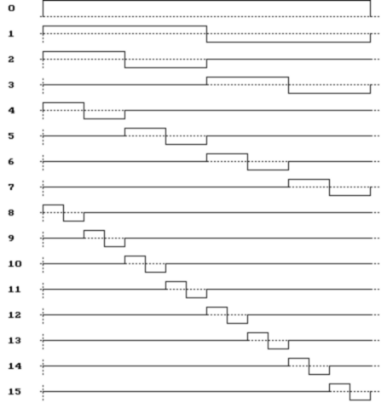
Figure 1. Haar basis functions (first 16 shown)
4. Model understudy and result analysis

In this section, we provide firstly studied model followed by obtained results.
Ethernet traffic traces deployed in our study have been captured on our University network. It is a self-similar traffic with Hurst parameter in interval 0.6-0.75.
On this traffic we have investigated dependencies between wavelet coefficients. As it can be seen in Figure 2, the dependencies between parent-child are very important. In this Figure, there is depicted correlation between wavelet coefficients of Haar basis. These results show us the importance of wavelet coefficients correlation and this have a major impact on the analysis and on a possibility of effective signal synthesis.

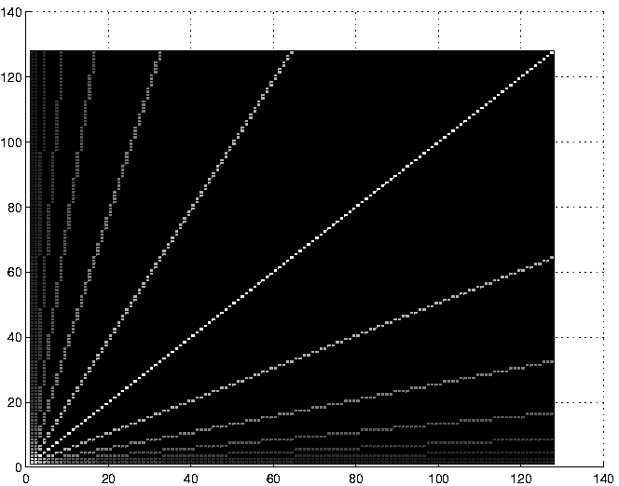
Figure 2. Correlation between wavelet base coefficients (Haar)
.
Figure 3 represents the same autocorrelation as previous one, but using real Ethernet traffic. Importance should be given to the values on diagonals. The main diagonal is not so important in our case. More Important are other diagonals, which directly show the dependencies between predecessors and successors. For example second diagonal reveals direct parent-child dependency.

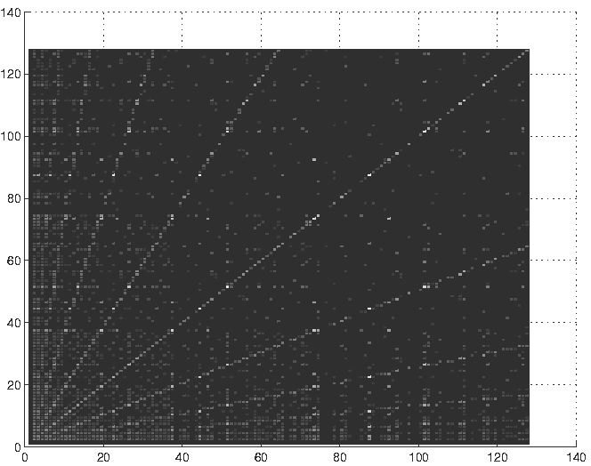
Figure 3. Correlation between wavelet coefficients (Ethernet signal)

Figure 4. Correlation between parent-child wavelet coefficients

We have deployed this behavior and have depicted these values in a tree graph (Figure 4). It is obvious that some way are more important and some less, which also implicates self-similarity phenomenon.

5. Conclusion

The statistical properties of the traffic, especially self-similarity, were discussed in this paper. We presented the dependencies between wavelet transform coefficients of Haar basis and between wavelet coefficients of real network traffic data signal (Haar functions were used in the wavelet decomposition process).
In the future we want to improve our model for more effective traffic synthesis. So in the analysis step we will try to use another type of othogonal wavelet functions, such as higher order Daubechies wavelets. And therefore we would create new traffic data generator.

6. Appendix and acknowledgments

This research was supported by the Grant Agency of the Ministry of Education of the Slovak Republic (VEGA) under No. 1/1048/04 and No. 1/0147/03, and by COST 279.

References

[1] H. E. Biaze, T. Atmaca and G. Hebuterne: Impact of shaping on network performance with self-similar traffic. In Proceedings of ICT'2000 May 2000
[2] V. Paxton and S. Floyd: Wide-area traffic: The failure of poisson modelling. ACM SIGCOM pp 257--268. Aug. 1994
[3] Vetterli,M., Kovacevic,J.: Wavelets and Subband Coding, Prentice Hall, 1995.

