Wavelet based Compression of Segmented Images using
Baseline Non-segmented Approach

Radoslav Vargic
Faculty of Electrical Engineering and
Information Technology
Slovak Technical University in Bratislava
Ilkovičova 3, 812 19 Bratislava, Slovakia
vargic@ktl.elf.stuba.sk
Ján Procháska
Faculty of Electrical Engineering and
Information Technology
Slovak Technical University in Bratislava
Ilkovičova 3, 812 19 Bratislava, Slovakia
prochaska@ktl.elf.stuba.sk

Abstract– We present an approach to compression of segmented images using wavelet transform followed by modified baseline coder. Baseline coder processes the spectral values from all segments in non-segmented style, i.e. together in one big block. Proposed scheme has comparative results as existing methods and retains its effectivity as the number of image segments increases.
- Introduction
For region and object oriented methods there are needed algorithms that can deal with arbitrarily shaped image regions, called segments. In this article we approximate the texture in segments using discrete wavelet transform (DWT) [4] defined on the rectangle circumscribing the given image segment. To partition the image into segments (see Fig. 1) we used an unsupervised segmentation method for color - texture regions used in [1].
In [5] and [6] is each segment coded separately and with bit budget proportional to segment size using coding scheme on Fig. 2. The SPIHT [3] algorithm we can use for coding of segments in non iterative process [6] or iterative process [5] which yields about 1% better compression results. In the next we compare our results to the results presented in [5] which contain also a baseline approach [4].

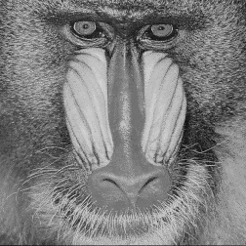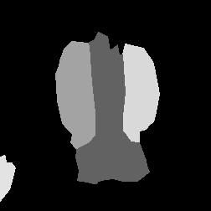
a) b)

- d)
- : Original Baboon image a) and masks for b) 5 c) 12 d) 30 segments

Segments

DWT
SPIHT
/ Baseline
coder

Encoded
Image

Image

Error: Reference source not found

- : Basic scheme for coding of segmented images

Our approach uses the above coding scheme with major modification. The spectrums of all segments are “joined” before compression. This spectrum is then coded with modified baseline algorithm in one step. The “joining” process is discussed later.
  - Baseline algorithm
In Baseline algorithm [4] are the spectral coefficients not partially sorted like in SPIHT [3]. Algorithm relies on the natural fading of the energy of spectral coefficients across the subbands. The tendency to transmit the more important information first is expressed also at the subband level The wavelet spectrum is quantized where each subband is handled separately. Entropic and run-length coder is used to code the resulting symbols.
- Modifications in Baseline coder for segmented images
When we code the image segments using Baseline algorithm separately [6] the coding overhad grows linearly with the number of segments. Advantage of that approach is, that the segments are isolated, so we can decode them individually. Transmission errors are not spread between the segments too.
To achieve higher coding efficiency for images with many segments we propose to join the spectral coefficients together according to their decomposition level. So input for the baseline algorithm are groups of coefficients that express the image details at the same resolution. For coding pourposes we adapted the implementation available from [4].
First, set of coefficients are created from the subbands of each segment on the same detail levels. Example of joining three square-like segment spectrums (Fig. 3) is demonstrated in Fig. 5.
Then are the DC components stored and detail coefficients passed to the Baseline algorithm, where they are quantized and entropy coded.

.

- : Example of 3 segments with sizes 8x8, 4x4 and 2x2 and joining of their DC components
Of course not all coefficients from each segment are enclosed to the joining process. Circumscribing a rectangle around each segment, results in black ares e.q. in areas which a not point of interest in terms of current segment.
To determine which spectral coefficients should be used in the joining process we have to choose the appropriate spectral coefficients, that spatially contribute to our image segments. For this purpose we used a spectral segment validity mask in the form depicted in Fig. 4, which has nonzero value for valid coefficients (coefficients that contribute to the segment). To produce the validity mask we can use the down sampling approach as in [2] or more rigorous and slower approach as in [6] which assures no information loss at this stage.
We tested both approaches for creating the validity mask. It turned out that the approach from [2] gives with proposed algorithm a little bit better results.
- Comparison and Results
The SPIHT approach in [5] (further referred as SPIHT_S, which means SPIHT with separate block coding) was used without arithmetic coding. This gave always a better image quality than a baseline approach with completely separate coding of blocks.
So we will compare our modified-baseline approach results to SHIHT_S. There was no interest to compare the absolute coding efficiency of both algorithms. We wanted mainly to test the behaviour of these two approaches as the number of segments grows and/or bit rate decreases.
For “Baboon” and down sampled “Lena” image are the numerical results shown in Tab. 1 and Tab. 2.

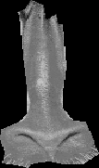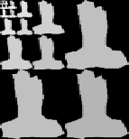

- : Segment “Baboon’s nose” and it’s spectral segment validity mask

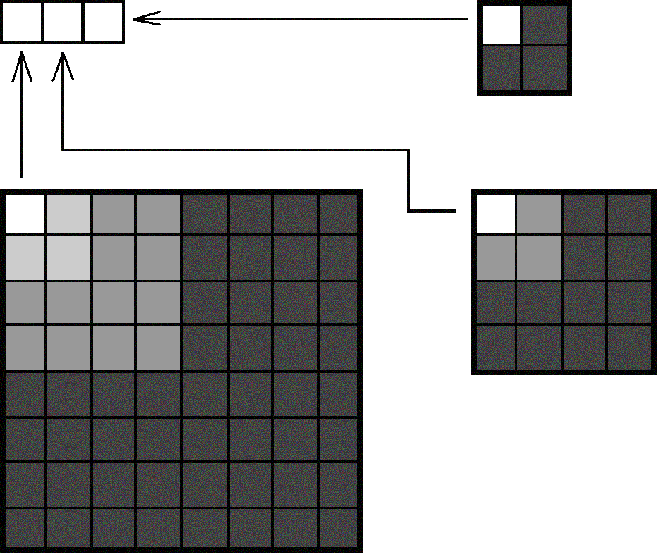
a) Joining of DC components
b) Joining of details at level 1
c) Joining of details at level 2

d) Joining of details at level 3

- : Example of joining the DC coefficients and details at different decomposition levels. Only the biggest segment contributes to all detail levels.

Tab. 1. Resulting PSNR values for both methods when coding Baboon [256x256] image using various segment numbers and bit rates. Used DWT with FBI 9/7 filters

Seg-ments | Bpp/ Method | 0.15 | 0.25 | 0.5 | 1
5 | SPIHT_S | 22.03 | 22.78 | 24.23 | 26.71
 | ModBC | 22.10 | 22.86 | 24.04 | 26.34
12 | SPIHT_S | 21.87 | 22.53 | 23.81 | 26.02
 | ModBC | 21.86 | 22.54 | 23.72 | 25.82
30 | SPIHT_S | 21.63 | 22.24 | 23.63 | 25.78
 | ModBC | 22.04 | 22.77 | 23.43 | 26.18
41 | SPIHT_S | 21.53 | 22.16 | 23.46 | 25.57
 | ModBC | 21.87 | 22.40 | 23.42 | 26.1

Tab. 2. Resulting MSE values for both methods when coding image Lena [256x256] image using various segment numbers and bit rates. Used DWT with FBI 9/7 filters

Seg-ments | Bpp/ Method | 0.15 | 0.25 | 0.5 | 1
12 | SPIHT_S | 25.91 | 27.61 | 30.43 | 33.88
 | ModBC | 25.85 | 27.07 | 30.26 | 33.43
29 | SPIHT_S | 24.99 | 26.6 | 29.11 | 32.37
 | ModBC | 25.86 | 27.43 | 30.26 | 33.53
49 | SPIHT_S | 24.49 | 25.97 | 28,46 | 31.58
 | ModBC | 25.24 | 27.16 | 29.75 | 33.24

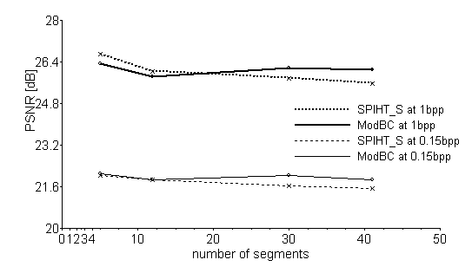
Fig. 6. Coding of segmented baboon Image, both SPITH and BC have approximately the same behaviour when number of segments is increased or bit rate is changed

When computing compression ration we take not in account the information amount needed to code segment boundaries. This amount is for both compared methods the same, thus irrelevant for comparison purposes. Some numerical results from Tab.1 are graphed in Fig. 6. The results show that modified baseline approach gains on performance against SPIHT_B as the number of segments grows. The decay difference in the sense of PSNR is most remarkable at the higher bit rates. Simulations on other segmented images showed similar behaviour.

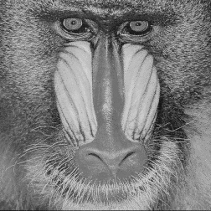
a) Original Baboon image 256x256, 8bpp

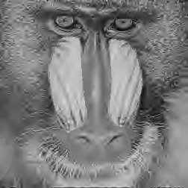
b) Modified Baseline coder, 5 segments, 0.15 bpp

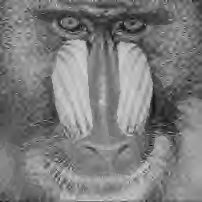
c) Modified Baseline coder, 41 segments, 0.15 bpp

Fig 5: Example of joining the DC coefficients and details at different decomposition levels. Only the biggest segment contributes to all detail levels.

- Conclusion
In this article we modified the baseline algorithm [4] to effectively code the image segments using wavelet transforms. As the number of segments grows, PSNR falls down slower than in SPIHT_S algorithm. From certain number of segments (depending on image) is presented approach with modified baseline algorithm more effective, regardless of the initial advantage of SPIHT_S algorithm.

References
- [1] T. Karlubíková et al., New Scheme for Region Approximation and Coding with Shape Independent Transform, Proc. Photogrammetric Computer Vision (PCV’02). Graz, Austria, 2002, ISPRS Commision III, Vol. 34, Part 3B, ISSN 1682-1750, pp. 214-217.
- [2] Y. Liu, S. Ranganath, X. Zhou, “Wavelet-based Image Segment Representation”, Electronics Letters, Vol. 38, No. 19, pp. 1091-1092, 2002.
- [3] A. Said, Pearlman, W., A. A New Fast and Efficient Image Codec Based on Set Partitioning in Hierarchical Trees, IEEE Transactions on Circuits and Systems for Video Technology, vol. 6, pp. 243-250, June 1996
- G. M. Davis, "Baseline wavelet transform coder construction kit,", 1997, (www.cs.dartmouth.edu /~gdavis/wavelet/wavelet.html)
- Vargic, R. Wavelet-Based Compression of Segmented Images, Proceedings of EC-VIP-MC 2003, Zagreb, Croatia , 2003, pp.347-351
- Vargic, R., Procháska J.: Zerotree and baseline approach for image segment compression , RTT2003,Častá-Píla, Slovak Republic, 2003, pp.263-265

